yacht_hydrodynamics

Shiva Sankar Modala

2023-02-10

## Installing the necessary packages for the problem ##  
  
#install.packages('readr') ## yacht_hydrodynamics.data is a large dataset. So, I used readr package in handling the data  
#install.packages('caret') ## To use machine learning models, I used caret to fit our model  
#install.packages('ggplot2') ## used ggplot2 for better visualizations of data  
#install.packages('lattice') ## Lattice is used to implement the trellis graphics for our data

# Loading the libraries  
library(readr)  
library(data.table)  
library(caret)

## Loading required package: ggplot2

## Loading required package: lattice

library(ggplot2)  
library(lattice)

# Reading the yacht_hydrodynamics.data as the table without the header  
yacht_hydrodynamics = read.table("https://archive.ics.uci.edu/ml/machine-learning-databases/00243/yacht_hydrodynamics.data", header = F)

# Assigning the column names for our dataset  
names(yacht_hydrodynamics) = c("longitude","Prismatic","displacement","beam-draught","beamlenght","fraude","residuary")  
head(yacht_hydrodynamics)

## longitude Prismatic displacement beam-draught beamlenght fraude residuary  
## 1 -2.3 0.568 4.78 3.99 3.17 0.125 0.11  
## 2 -2.3 0.568 4.78 3.99 3.17 0.150 0.27  
## 3 -2.3 0.568 4.78 3.99 3.17 0.175 0.47  
## 4 -2.3 0.568 4.78 3.99 3.17 0.200 0.78  
## 5 -2.3 0.568 4.78 3.99 3.17 0.225 1.18  
## 6 -2.3 0.568 4.78 3.99 3.17 0.250 1.82

# Creating the data partition for our data having 80% our data for the training. So the rest 20% is for testing.  
# I used the caret package to perform a 80/20 test-train split  
cd = createDataPartition(y = yacht_hydrodynamics$residuary , p = 0.8, list = FALSE)

# Separating the dataset for the train data  
train_data = yacht_hydrodynamics[cd,]

# Separating the test data without the output label data.  
test_data = yacht_hydrodynamics[-cd,]

# Applying the linear regression model for the dataset  
# Applying the multiple linear regression   
lm1 = lm(yacht_hydrodynamics$residuary~yacht_hydrodynamics$longitude + yacht_hydrodynamics$Prismatic +  
 yacht_hydrodynamics$displacement + yacht_hydrodynamics$`beam-draught` + yacht_hydrodynamics$`beam-draught` +  
 yacht_hydrodynamics$displacement + yacht_hydrodynamics$fraude,  
 data = train_data)

# creating a function for the mean square error   
mse = function(y, yt){  
 return (mean((y - yt)^2))  
}

# Applying the mean square error for the residuary and the fitted values for the linear regression model.  
msee = mse(yacht_hydrodynamics$residuary, lm1$fitted.values )  
msee

## [1] 78.47651

cat("\n The MSE for the training data is = ", msee)

##   
## The MSE for the training data is = 78.47651

cat("\n The Root mean square error for the train data is = ", sqrt(msee))

##   
## The Root mean square error for the train data is = 8.858697

cat("\n The summary for the r-squared data for the linear model is = ",summary(lm1)$r.sq)

##   
## The summary for the r-squared data for the linear model is = 0.6574487

# train control specify the resampling scheme  
# I used the caret package to perform a bootstrap from the full sample dataset with N=1000 samples  
train = trainControl(method = "boot", number = 1000)

lm2 = train(residuary~., data = train_data, method = "lm" )

# summary of the model  
summary(lm2$resample$RMSE)

## Min. 1st Qu. Median Mean 3rd Qu. Max.   
## 8.243 8.679 9.306 9.109 9.478 10.337

summary(lm2$resample$Rsquared)

## Min. 1st Qu. Median Mean 3rd Qu. Max.   
## 0.5690 0.6301 0.6483 0.6457 0.6580 0.7025

# Plotting a histogram for the resampled data and the root mean square error  
hist(lm2$resample$RMSE, xlab = "RMSE", main = "Histogram of RMSE")

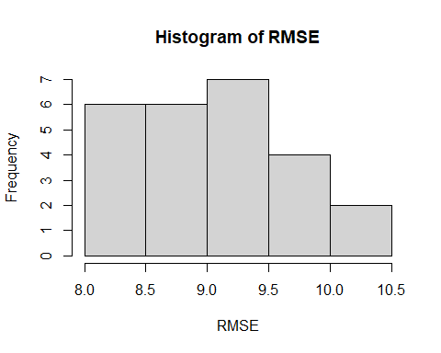

# applying the mean for the resampled data as the mse2  
mse2 = mean(lm2$resample$RMSE)^2  
mse2

## [1] 82.96775

cat("\n Training MSE for the bootstrap model is = ", mse2)

##   
## Training MSE for the bootstrap model is = 82.96775

cat("\n Training RMSE for the bootstrap model is ", mean(lm2$resample$RMSE))

##   
## Training RMSE for the bootstrap model is 9.108663

cat("\n Training Mean R-squared for the bootstrap model is ",mean(lm2$resample$Rsquared))

##   
## Training Mean R-squared for the bootstrap model is 0.6457281

predVals_boot = predict(lm2,test_data)

cat("\n From the above observations, there is no difference in performance between the original and bootstrap models.")

##   
## From the above observations, there is no difference in performance between the original and bootstrap models.